Maharshi Patanjali Vidya Mandir Prayagraj
HOLIDAYS HOME WORK (2020-21)
Of
Class XI- Humanities Stream

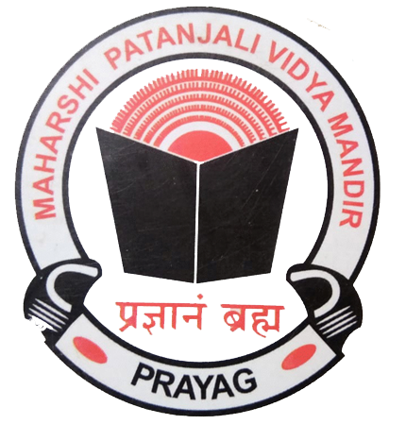

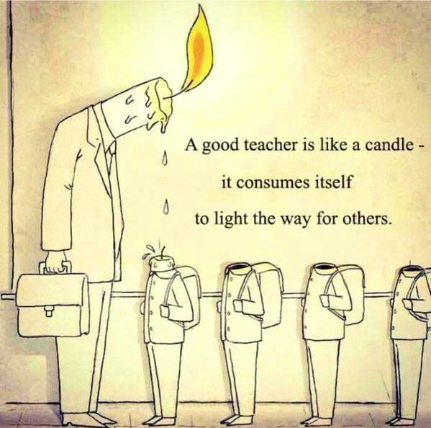
"You learn something every day if you pay attention. 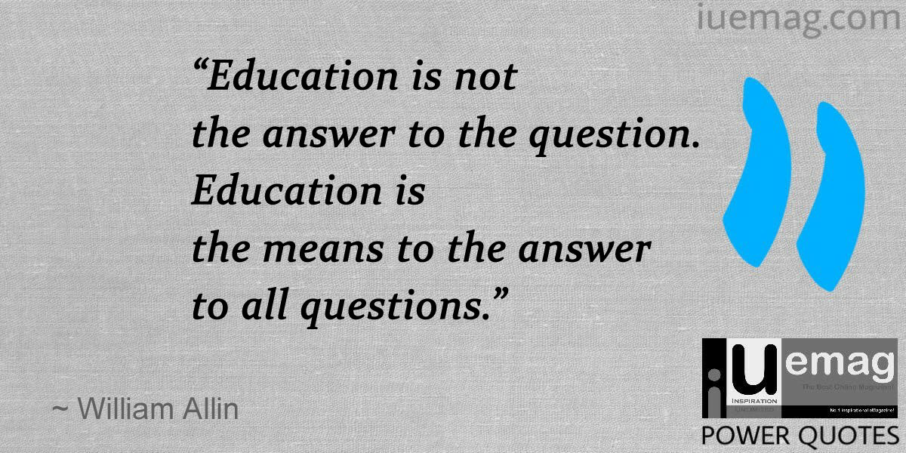
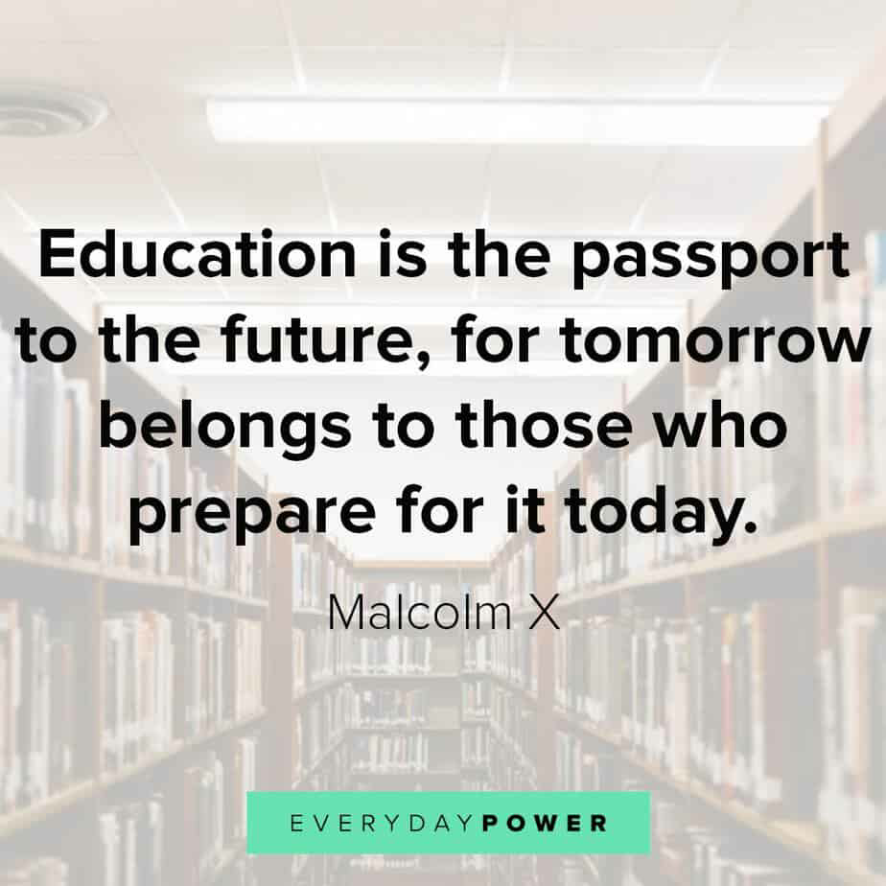
English | Learn the Question and answers of the following lessons:-  HORNBILL  - The Portrait of a Lady  - A Photograph (poem)  SNAPSHOTS  - The Summer of the Beautiful White Horse  Practice the exercises on the given topic in  Grammar:-  1.Tenses  Make a video in pairs, on the topics given:-  ( please follow these Instructions :-)  *Video should be of 1 minute 30 seconds duration and have to be sent in a compressed format.  * You will speak only on the topics given.  * Keep the video safely as you have to send it to the teachers in July.  TOPICS FOR ONE AND A HALF MINUTE CONVERSATION  1.Trying times  2. How to increase our immunity  3. Time Management  4. How I miss my school  5. My Ideal  6. Unpolluted nature- lockdown-lesson  OR  ROLEPLAY: TOPICS (Individual) Keep a hardcopy of the script  - Policeman  - Doctor  - Journalist  - Army Personnel  - Teacher  - Businessman
Psychology | - Revise the chapter “What is Psychology? Thoroughly.  - Define all the key terms given at the end of the chapters.  - Answer all the questions given at the end of chapter neatly in your notebook.  - Surf the internet and obtain the names of some books or films, which have reference to application of Psychology?
Economics | Introductory Micro Economics –  - Central Problems of An Economy  Complete all the exercises and the questions given.  Practice doing numerical related to Production Possibility curve, MRT, MOC and Opportunity Cost.  Practice doing the diagrams related to rotation and shifting of PP curve  Read the chapter Consumer Equilibrium.  Statistics For Economics –  Read the chapter – Introduction Of Statistics  Learn and write various definitions of Economics, definition of Statistics, both singular and plural, sense, scope importance and distrust of Statistics.  Read the chapter Collection Of Data.  .
Physical Education | - Revision of unit I  - Make shorts notes of various topic – (athletic, basketball, football)  - Practice of Asana ( tadasana, padmasana, Shashankasana)  - Practice of meditation  - Practice of home yoga fitness workout daily .
Legal Studies | Read unit I from the CBSE e book sent to you  Do all the objective type questions of chapter 1 and 2 from the CBSE book  Revise what was done in the class  Make the legal Studies project  Guide lines for the project  Make a project on any fundamental right  It should include the following headings  Article- Its words, meaning, commentary  Explanation of the right  Decided cases on the right

“The aim of education should be to teach us rather how to think, than what to think — rather to improve our minds, so as to enable us to think for ourselves, than to load the memory with thoughts of other men.”

What we learn with pleasure we never forget.”

“Education is the passport to the future, for tomorrow belongs to those who prepare for it today.”

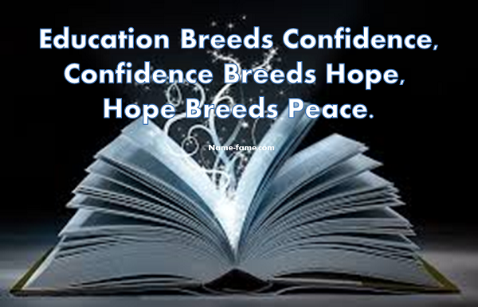

ENJOY YOUR HOLIDAYS

